SQL Joins Exercise
Practicing INNER JOIN, LEFT JOIN, and FULL OUTER JOIN on a five-table retail dataset using Databricks
Creating 5 tables
Table 1:Users
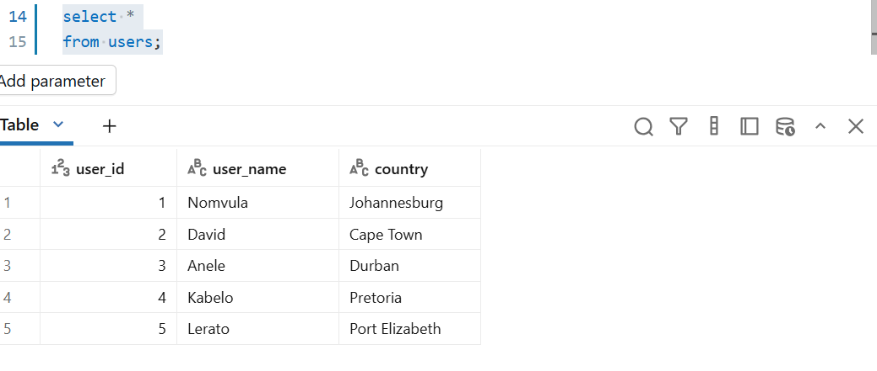
Table 2:plans

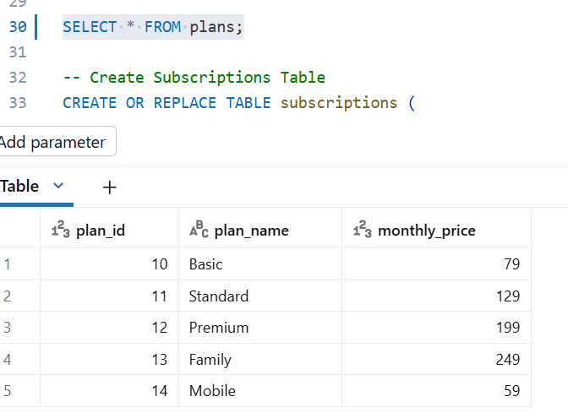
Table 3: subscriptions 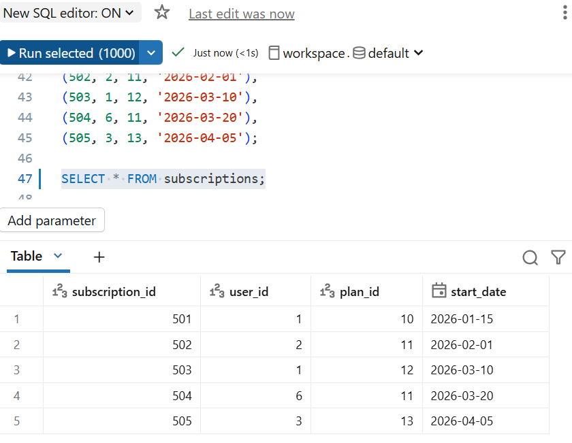
Table 4:shows
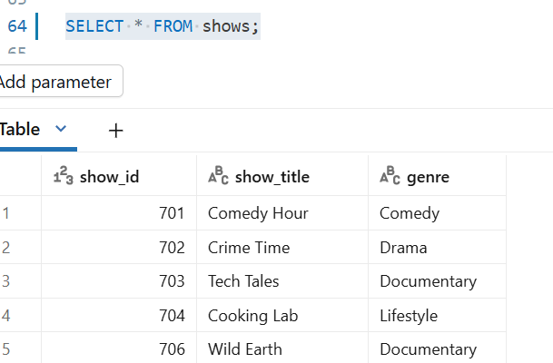
Table 5: Viewing_sessions
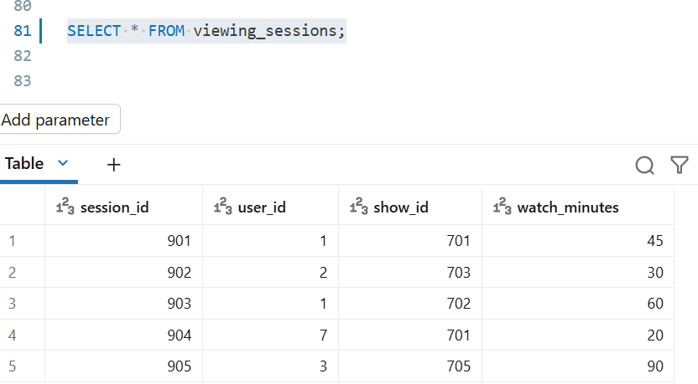
Part A — INNER JOIN
Q1
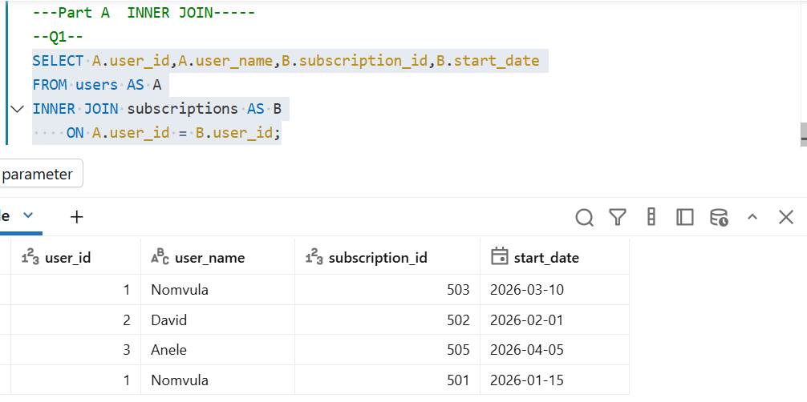
Q2:
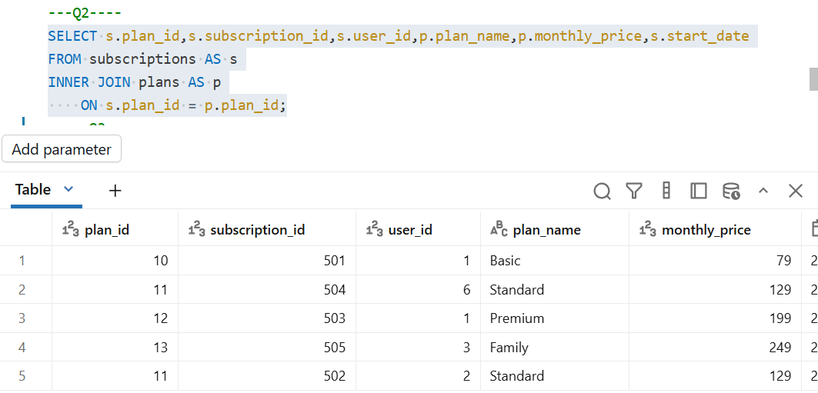
Q3:
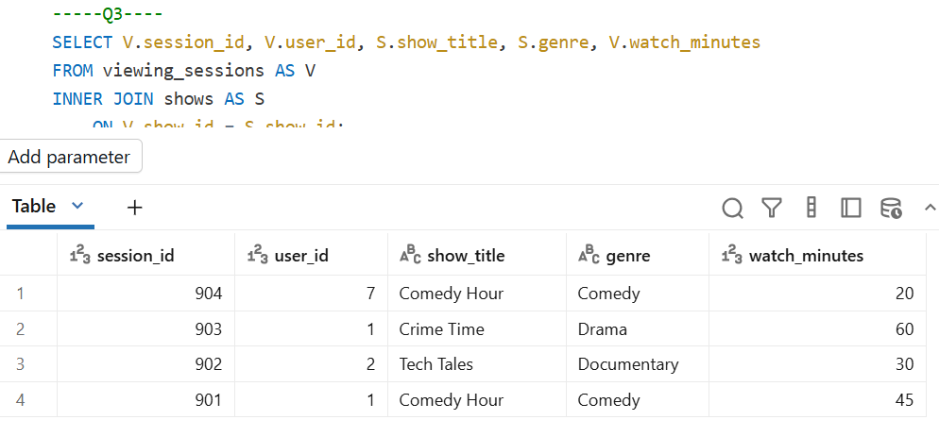
Q4:
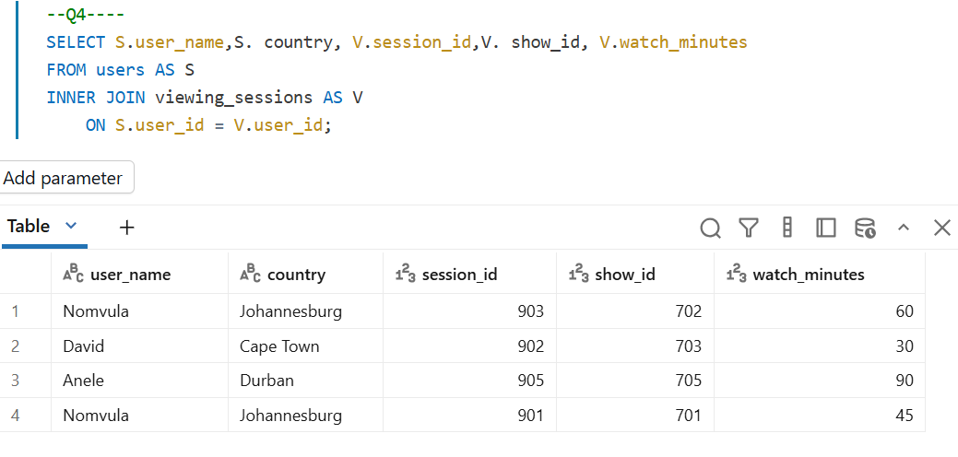
Q5:
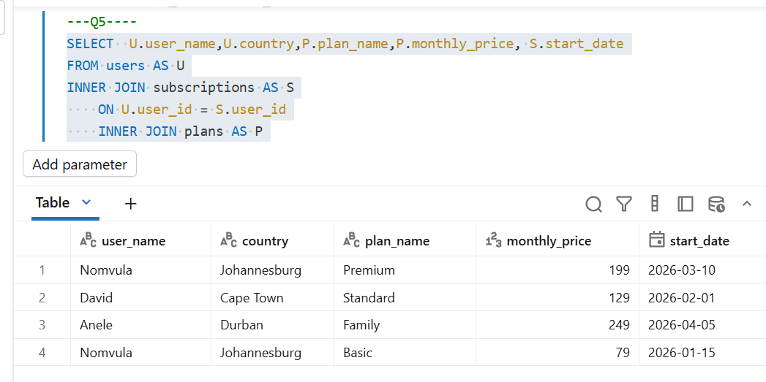
Part B — LEFT JOIN
Q6:
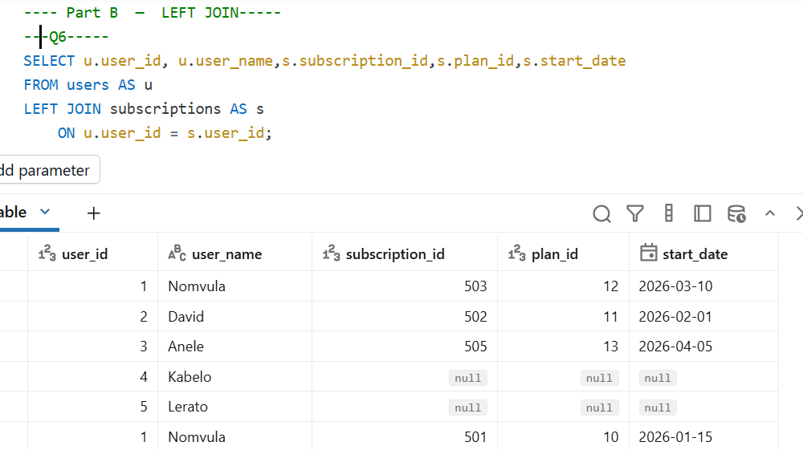
Q7:
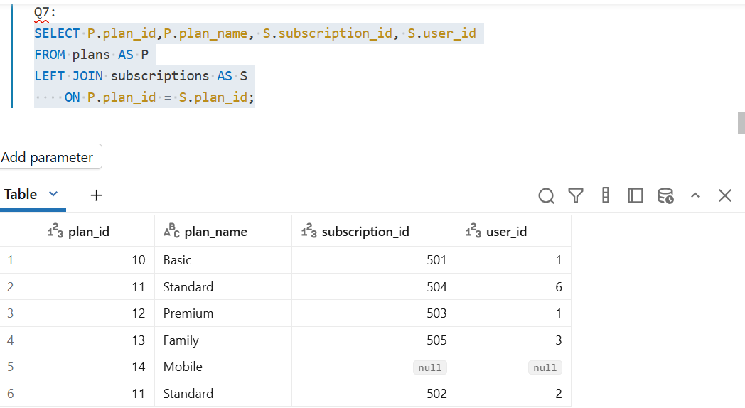
Q8:
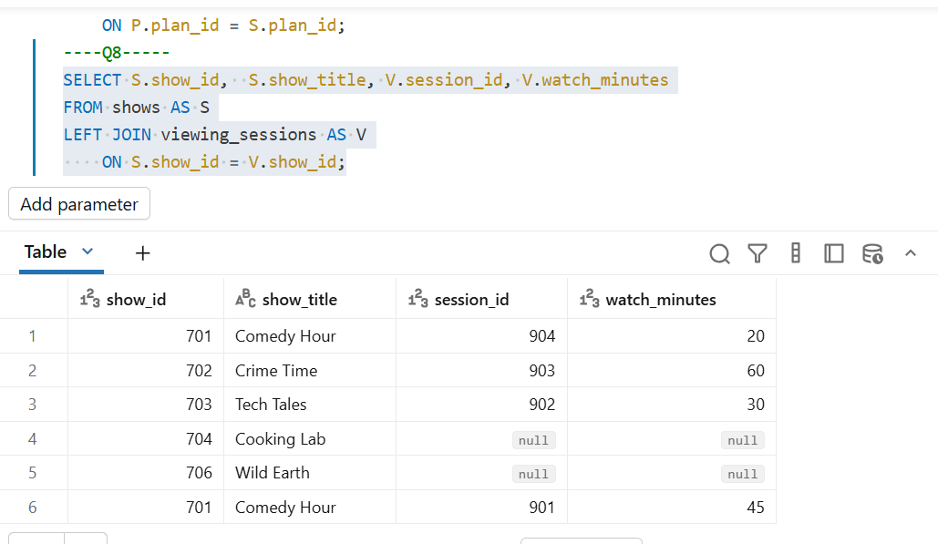
Q9:
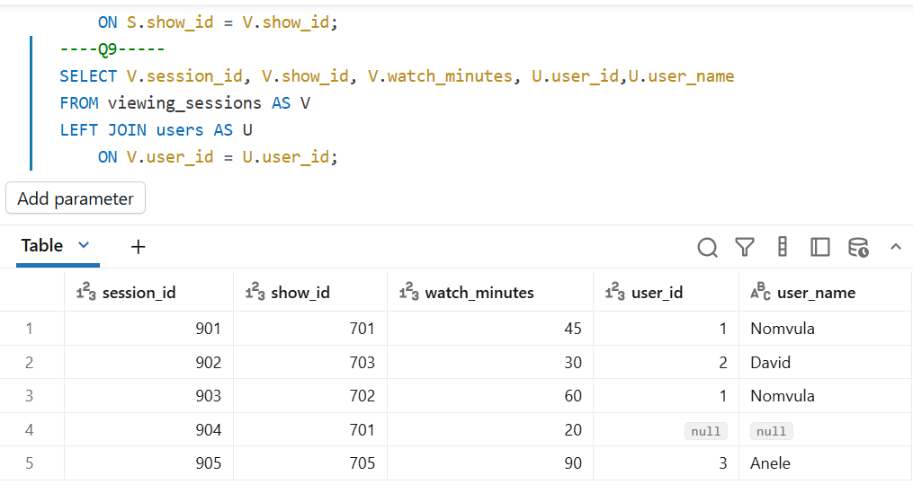
Q10:
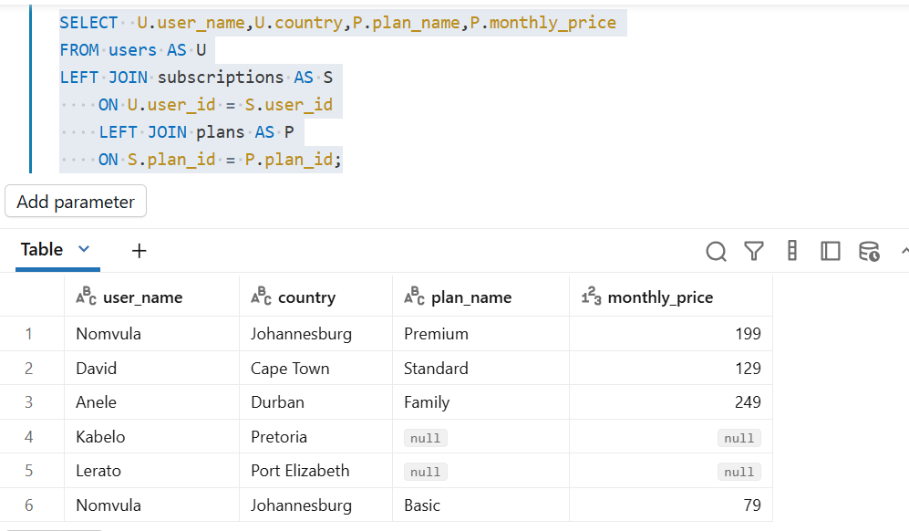
Part C — FULL OUTER JOIN
Q11:
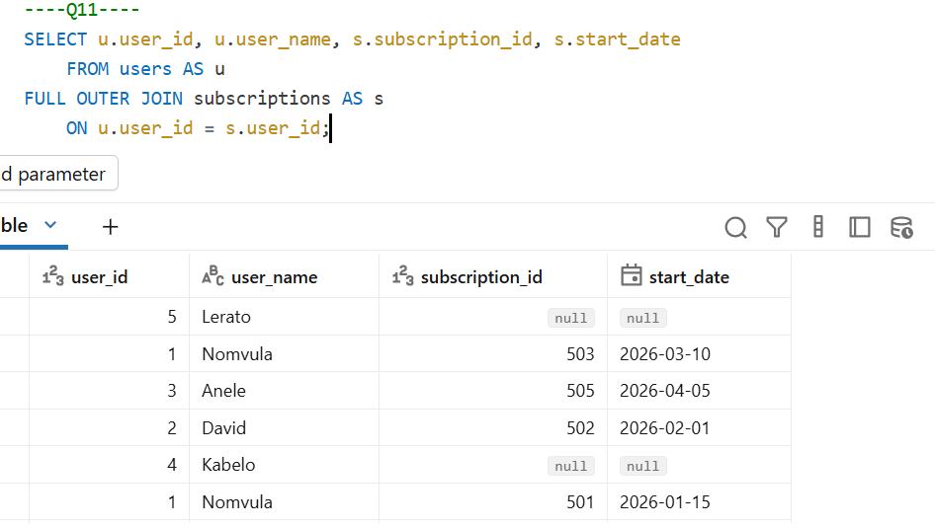
Q12:
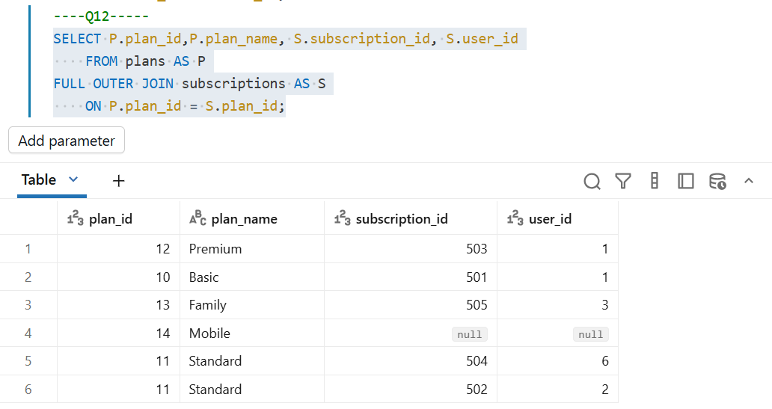
Q13:
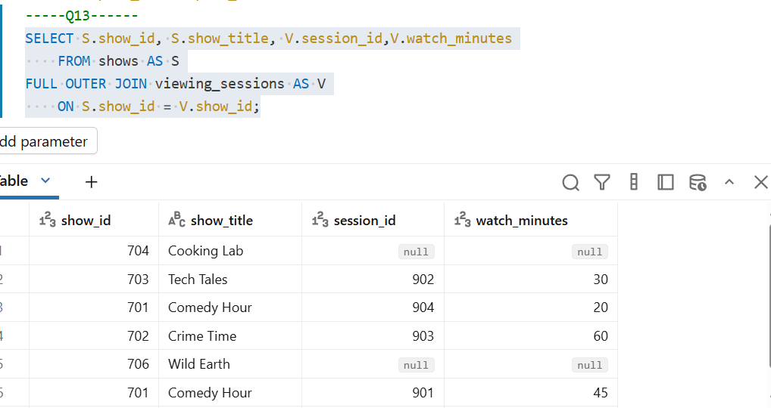
Q14:
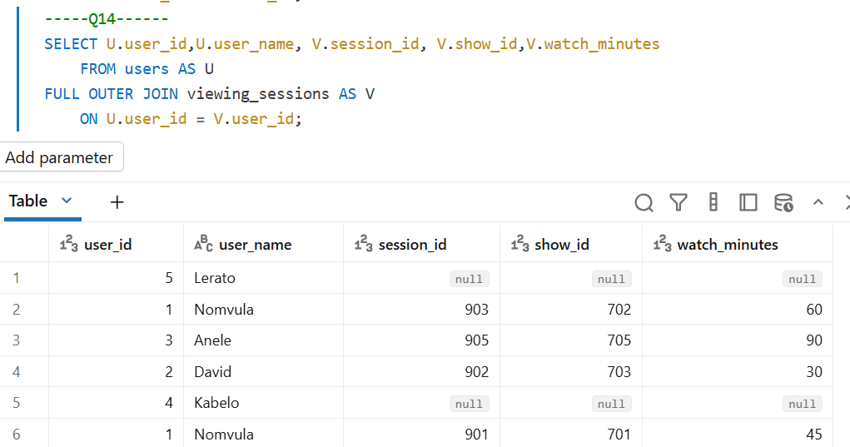
Q15:
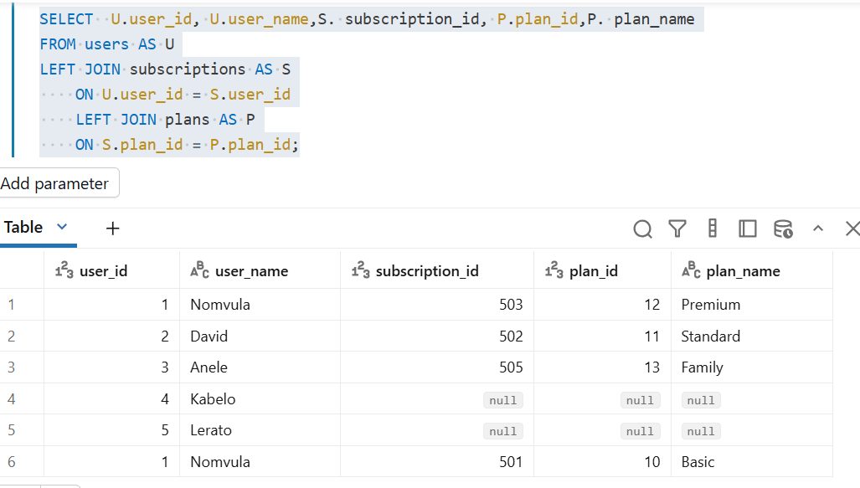
Bonus Challenge
BONU S 01: Which users have not subscribed to any plan?
-Kabelo and Lerato
BONU S 02 Which subscriptions reference users that do not exist in the users table?
-Subscription_id 504
BONUS 03: Which shows have never been watched?
-Cooking Lab and Wild Earth
BONUS 04: Which viewing sessions reference shows that do not exist?
-Session_id 905
BONUS 05: Which plans have no subscribers?
-plan_id 14

